**KUOYO KOCHIA BOYS’ HIGH SCHOOL**



**FORM TWO**

**COMPUTER STUDIES- MARKING SCHEME**

**NAME ___________________________________ ADM NO_________ Stream______ Date _________**

**451/1**

**Computer studies**

**Term 2 2025**

**TIME: 2HOURS**

**MID-TERM TWO EXAMINATIONS 2025**

**INSTRUCTIONS TO THE CANDIDATES**

1. *Write* ***your name*** and ***stream*** *and* ***Admission number*** *in the spaces provided above*
2. *Answer* ***all*** *the questions in* ***in this paper***
3. *All answers MUST be written in the spaces provided on this question paper.*
4. *This paper consists of 5 printed pages. Candidates should check carefully to ascertain that all the pages are printed as indicated and no questions are missing.*
5. *Candidates should answer the question in English*

**FOR EXAMINERS” USE ONLY**

|  |  |
| --- | --- |
| **MAXIMUM SCORE** | **CANDIDATE % SCORE** |
| **100** |  |

1. a) Define the term booting as used in computers. (1 mark)

* **Booting is the entire process of making a computer ready for use**

b) State **TWO** ways of warm booting a computer. (2 marks)

* **using the restart button on the power options**
* **Pressing CTRL+ALT+DEL on the keyboard**

1. Computers can be classified into different categories based on various parameters. One of these parameters is **functionality**, explain how computers are classified based on functionality, use diagrams where necessary.

(6 marks)

* **Digital computers, process data in discrete form**
* **Analog computer; Process data in continuous form**
* **Hybrid computers, process data in both discrete and continuous form**.

1. List **TWO** factors to be considered when purchasing computer hardware. (2 marks)

* **Cost**
* **Warranty**
* **Portability**

1. a) Briefly explain the meaning of the term **computer laboratory. (**2 marks)

* **A room set aside, equipped with computing facilities, to facilitate teaching and learning of computer studies to take place**

b) Explain why gaseous fire extinguisher is preferred over the Water and powder fire extinguisher in a computer laboratory. (2 marks)

* **Water fire extinguisher can cause rusting to the metallic parts of the computer when used**
* **Water completes circuit hence can cause short-circuit when used.**
* **Powder can cause clogging to the moving parts of a computer like keyboard, leading to malfunctioning.**

c) State any **TWO** factors to consider when setting up a computer laboratory. (2 marks)

* **Security of the area**
* **The area should be well ventilated**
* **Should be far from a flooding area**
* **Floor space/number of machines**

1. Write the following acronyms in full as used in computer science. (3 marks)

* MICR: **Magnetic ink character reader**
* UPS: **uninterruptible power supply**
* ALU: **Arithmetic logic** unit

1. Mention **THREE** reasons why a calculator is a computer. (3marks)

* **A calculator accepts users input**
* **A calculator processes the input data**
* **A calculator Gives output to the user**

1. a) What do you understand by the term a **microcomputer**. (1 mark)

* **A microcomputer is a computer whose CPU has been implemented using a microprocessor**

b) State and explain any **TWO** microcomputers that you know. (4 marks)

* **Desktop: placed on top of an office desk while in use**
* **Laptop: Portable and placed on the laps of user while in use**
* **Palmtops, can fit into user’s palm or pocket.**

1. State four categories of keys on the computer key board. (4 marks)

* **Number keys**
* **Alphanumeric Keys**
* **Function Keys**
* **Special Keys.**

1. State **FOUR** major classifications of Computer hardware. (4 marks)

* **Input Devices**
* **Output Devices**
* **CPU**
* **Storage Devices**

1. a) Define the term **Operating System** as used in computers. (1 mark)

* **Operating system is a system software that act as an interface between the user and the computer system**

1. What are the **THREE** ways used to classify the operating system. (3 marks)

* **According user interface**
* **According to number of users in can support**
* **According to Number of tasks**

1. The figure below shows an extract from a computer program.

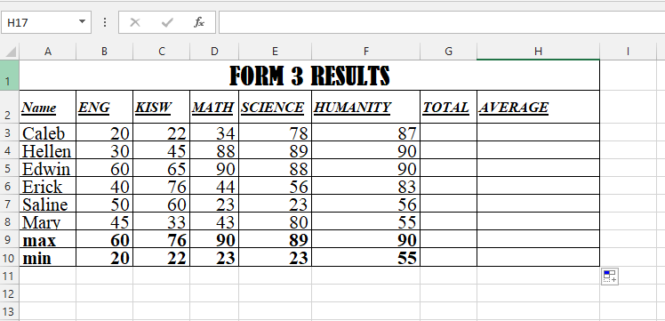

1. Name the program from which the extract above was taken. (1 mark)

* **Ms Excel spreadsheet**

1. Define a **cell** as used in the program shown above. (1 mark)

* **A cell is the intersection between rows and columns where data is entered.**

1. State **FOUR** formatting features used in the extract above. (4 marks)

* **Bolding**
* **Underlining**
* **Italising**
* **Merge and center**

1. Write the function the that can be entered in to cell **G3** AND copied downwards to calculate the TOTALS **(2 marks)**

* **=SUM(B3:F3)**

1. Write the function the that can be entered in to cell **H3** AND copied downwards to calculate the **AVERAGE (2 marks)**

* **=AVERAGE(B3:F3)**

1. Give two reasons to justify why unstable power supply is considered a threat. (2 marks)

* **Can lead to hard disk crushing**
* **May lead to loss of unsaved data**

1. State **TWO** characteristics of Fifth generation computers. (2 marks)

* **Technology used was artificial intelligence**
* **Consume less power, produce less heat**
* **Portable and small in size**
* **Huge memory capacity**

1. What is a relational database management system? (1 mark)

* **It is a database model where information is stored in related structures called tables or relations**

1. a) List **THREE** database objects (3 marks)

* **Forms**
* **Tables**
* **Query**
* **Report**

**(Deny Macros and modules)**

1. Differentiate between a **Macros** and a **Module** as used in Databases (2 marks)

* **A macro is a feature used to automate database operations**
* **A module is a programming environment embedded in Ms access**

1. Write the query criteria you would use to display employees details from a payroll database for employees who earn a basic salary that is Ksh. 12,000 and above. (1 mark)

* **>= 12000**

1. Describe the following mouse terminologies. (4 marks)
2. **Clicking-** the pressing and releasing the left mouse button once. Usually used to select an object/item in screen.
3. **Right** -**clicking**- the pressing and releasing the right mouse button once, usually used to open menus, and selecting an item/object.
4. **Double- clicking-** pressing and releasing the left mouse button twice in a quick succession. Used to open files and start a program.
5. **Drag and drop-** used t drag an item from one location to another location on the screen. using the procedure below; -
6. The figure below shows an input device.
7. Classify the input device below (1 mark)

* **Speech recognition device**

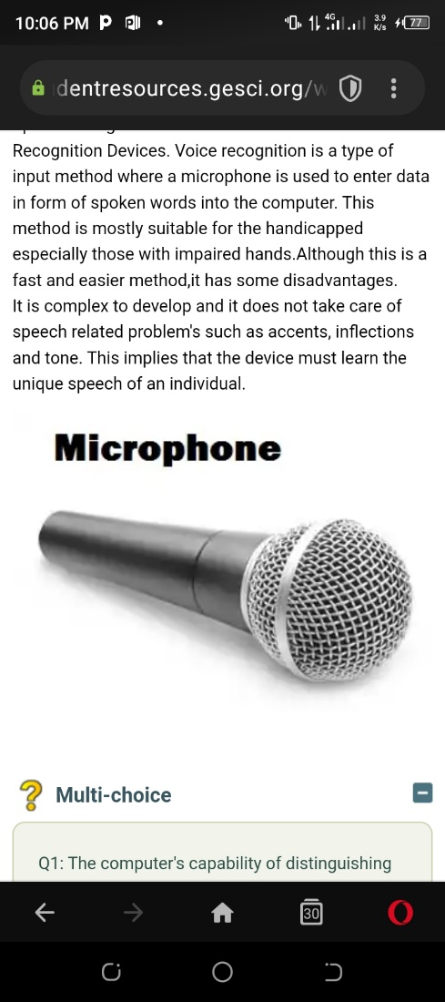

1. Highlight **TWO** advantages of using the device above (2 marks)

**Advantages;**

* **This method is suitable for the handicapped especially for those with impaired hands.**
* **It is faster and easier method.**
* **It is suitable for high multitude.**

1. State TWO characteristics of the **RAM** (2 marks)

**Characteristics of RAM.**

* **Data can be read and written on it.**
* **It is volatile; - its content disappears when the computer is switched off.**
* **Its content is user defined i.e., the user dictates what is to be contained in the RAM.**

1. List **TWO** types of RAM (2 marks)

* **Dynamic RAM**
* **Static RAM**

1. a) Differentiate between hardcopy output and a softcopy output (2marks)

* **Softcopy refers to intangible output mainly displayed on the screen or through other output devices like speakers.**
* **Hardcopy is a tangible output mostly displayed in papers by devices such as printers and plotters**

1. A monitor is one of the output devices. Below are some monitor displays
2. Identify the figures i and ii below ( 2 mark

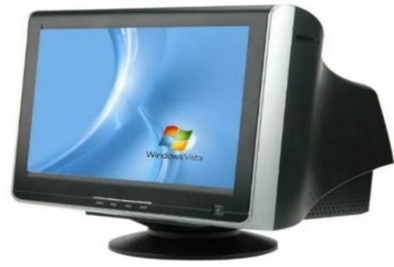

1. **Cathode Ray Tube(CRT) monitor**

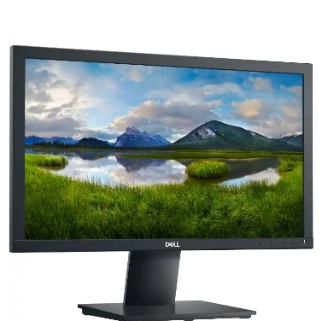

1. **Flat panel monitor**State THREE differences between the figure i and figure ii (3 marks)

|  |  |
| --- | --- |
| **CRT monitor/FIG 1** | **Flat-panel display / FIG II** |
| The screen is slightly curved outwards | The screen is flat |
| Heavy hence less portable | Lighter hence more portable |
| Consumes a lot of power | Consumes less power |
| Poor resolution | Higher resolution |

1. Give three examples of figure ii monitors available in the market today. ( 3 marks)

* ***Liquid Crystal Display (LCD)***
* ***Gas Plasma Display (GPD)***
* ***Thin-Film-Transistors (TFTs)***
* ***Field Emission Displays (FESs)***

1. Differentiate between the **Save As** and the **Save** Command as used in Word Processors (2 marks)

* **Save As; - Saving a document for the first time**
* **Save; updating already existing document**

1. There are numerous Keyboard shortcuts in computer that are effective in Microsoft word. Explain What Can be achieved by the following Shortcuts in Microsoft word. (3 marks)

* **CTRL + B: bolds highlighted text**
* **CTRL + U: underlines highlighted text**
* **CTRL + A: highlight the entire document**

1. What is the units for measuring the processor speed in computers? (1 mark)

* **Hertz /Hz**

1. Mr. Wekesa went to a computer shop and saw a machine with the following specifications

Explain what these specifications mean (4 marks)

* **500 GB HDD: Hard disk size is 500 GB**
* **8GB: RAM size**
* **19” Screen size is 19 inches**
* **16.2 GHz processor speed**

1. Name four criteria used when selecting a printer.

* ***Print quality***
* ***Initial cost***
* ***Running cost***
* ***Speed***
* ***Color printing***

1. Pamtex construction company intends to buy an output device they can use to produce road maps. Which device would one advice the company to buy and why?

* ***Plotters***
* ***Plotters are specialized output devices designed to produce high quality graphics in a variety of colours. Mostly used for printing geographical, architectural and engineering drawings e.g., maps, advertisement posters****.*

1. Give three examples of operating systems**. ( 3 marks)**

* ***Microsoft Windows (95, XP, Vista,2000,7,8, ,10)***
* ***UNIX***
* ***Linux***
* ***Macintosh (MacOS).***
* ***Ubuntu***

**THIS IS THE LAST PRINTED PAGE**

**© 2025 Term Two mid-term exam- marking scheme**

**Kuoyo Kochia**